**TUTORIAL 3**

**3.Prepare a detailed test report with test cases, results, and bug report for a tested module.**



**Test Report:** Cart & Checkout Module

**1. Module Name:**

Cart & Checkout Module

**2. Objective:**

To validate the cart management and checkout process of Nykaa’s e-commerce application, ensuring smooth product addition, Price calculation, order placement, and payment gateway integration.

**3. Environment Details:**

**Parameter Value**

Application Nykaa App(Android/OS,web) Test Environment QA Server

Browser Chrome v116/ Safari v15

Mobile Device Android 13, ios 16

Database PostgreSQL 12

**4. Test Scenarios Covered:**

1. Add product to cart
2. Remove product from cart
3. Update quantity in cart
4. Price recalculation after changes
5. Apply discount/Coupon code
6. Proceed to Checkout
7. Payment gateway redirection
8. Order confirmation email/SMS

**5. Test Cases and Results**

**TC_ID:- 01**

**Test case Description:-** Add product to cart

**Input data:-** Select product → click add

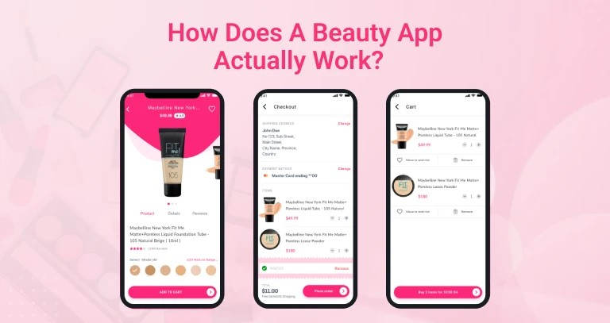

**Expected Result:-** Product add to cart

**Actual Result:-** As accepted

**Status:-** ✔️Pass

**TC_ID:- 02**

**Test case Description:-**Remove product from cart

**Input data:-** Cart with 1 product→Remove

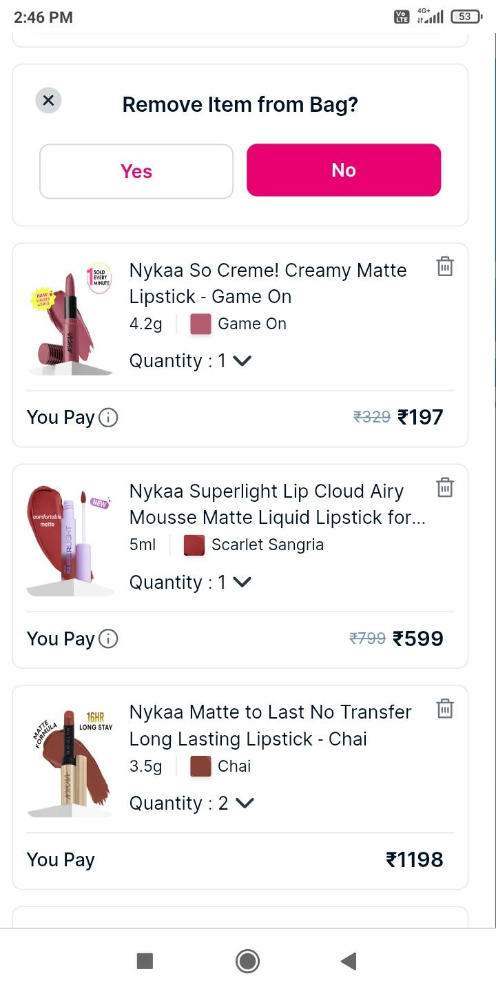

**Expected Result:-** Product removed, cart empty

**Actual Result:-** As accepted

**Status:-** ✔️Pass

**TC_ID:- 03**

**Test case Description:-** Update quantity

**Input data:-**  Change qty from 1→3

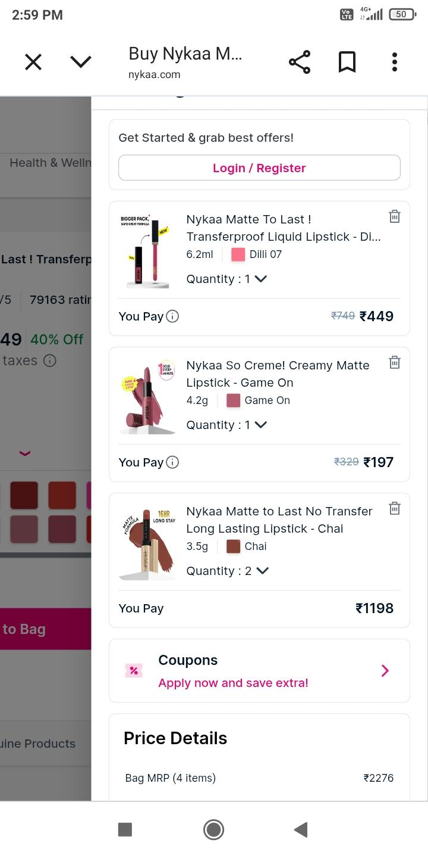

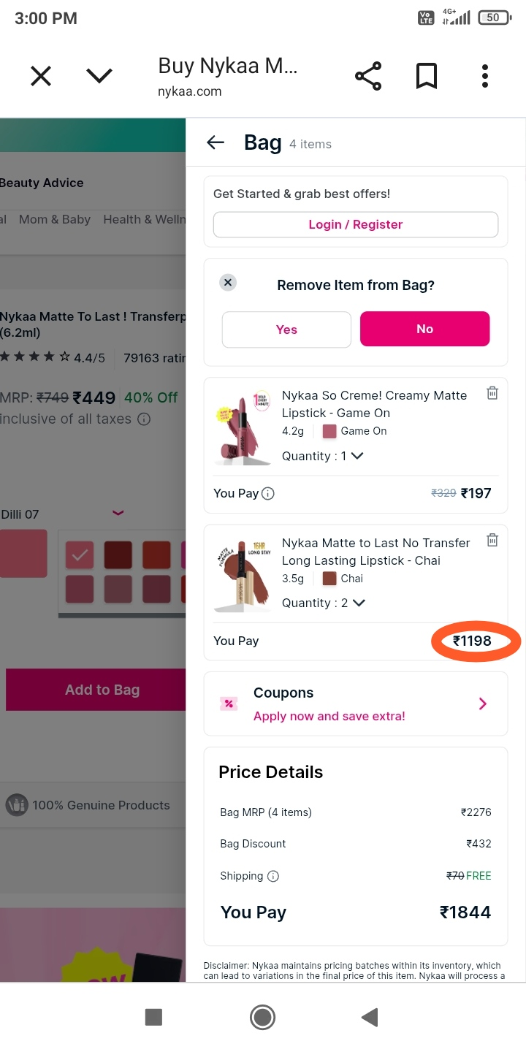

**Expected Result:-** Price recalculated correctly

**Actual Result:-** Total Price incorrect

**Status:-** ❌Fail

**TC_ID:- 04**

**Test case Description:-**Apply discount code

**Input data:-** Coupon:NYKAA500

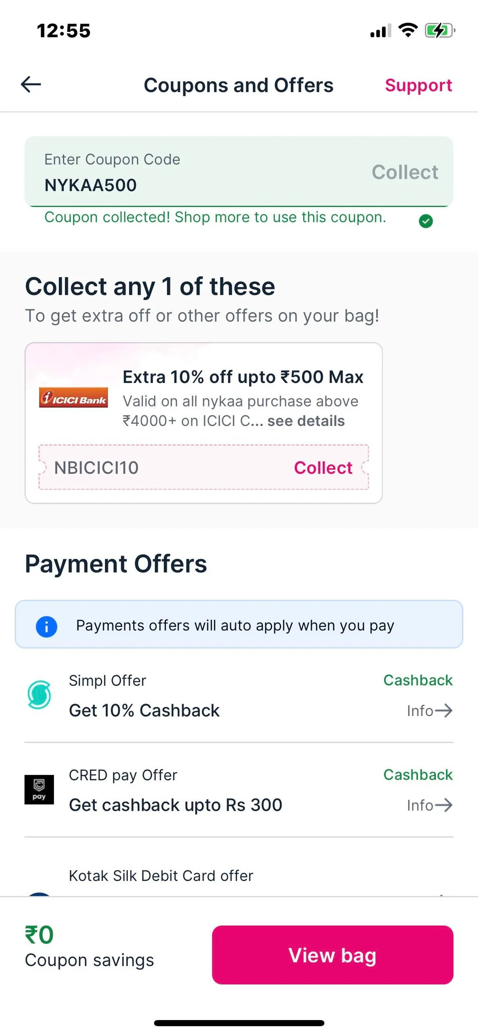

**Expected Result:-** Discount applied

**Actual Result:-** As accepted

**Status:-** ✔️Pass

**TC_ID:- 05**

**Test case Description:-** Invalid Coupon code

**Input data:-** Coupon:HELLO123

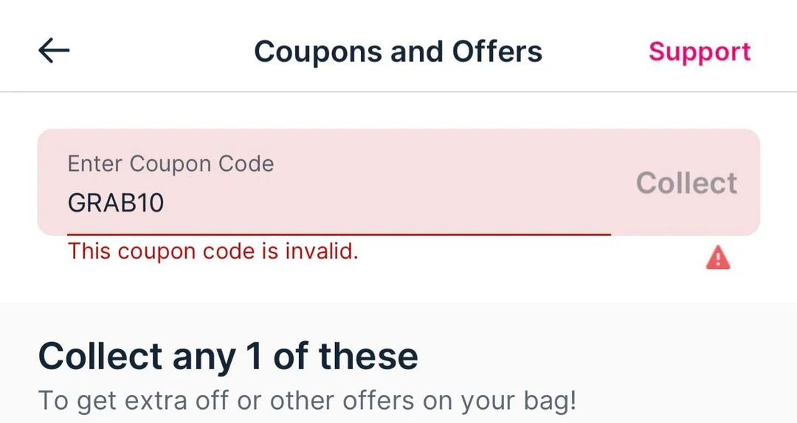

**Expected Result:-** Error: “invalid coupon”

**Actual Result:-** As accepted

**Status:- ✔️**Pass

**TC_ID:- 06**

**Test case Description:-** Proceed to Checkout

**Input data:-** Cart with items →

Checkout

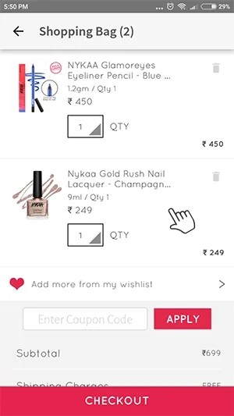

**Expected Result:-** Redirect to address / payment page

**Actual Result:-** As accepted

**Status:- ✔️**Pass

**TC_ID:- 07**

**Test case Description:-** Payment gateway

**Input data:-** Select UPI → pay

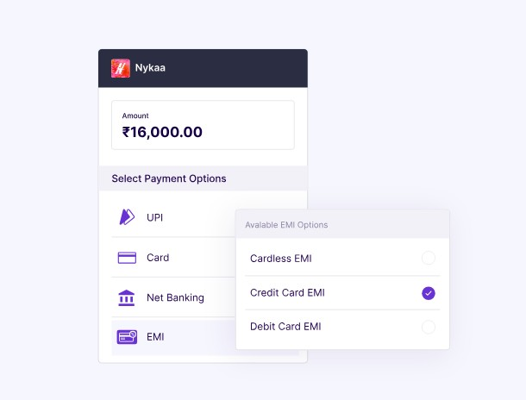

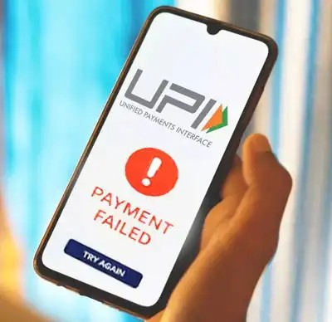

**Expected Result:-**Redirect to UPI gateway

**Actual Result:-** App crashed

**Status:- ❌**Fail

**TC_ID:- 08**

**Test case Description:-** Order confirmation

**Input data:-**Place order successfully

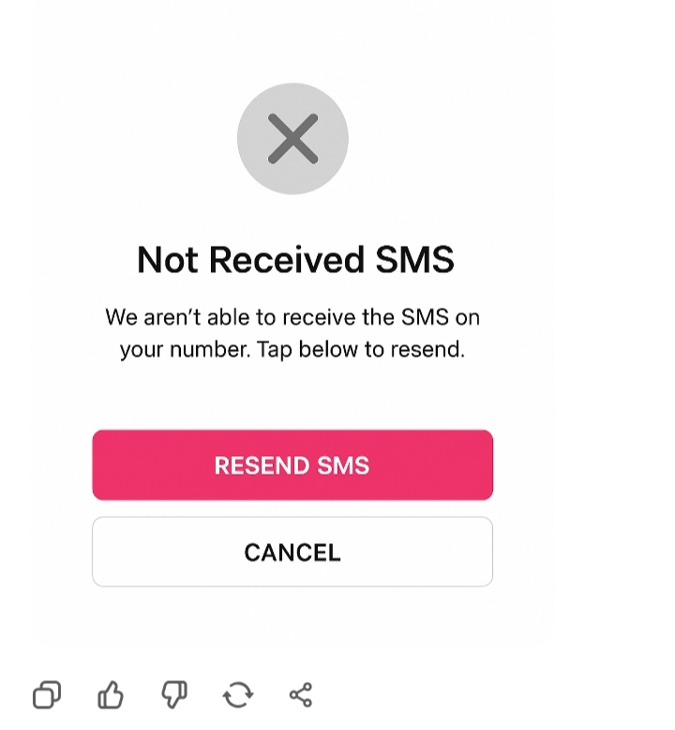

**Expected Result:-** Confirmation email / SMS sent

**Actual Result:-** No SMS received

**Status:-** ❌Fail

**6. Summary of Test Results**

**Total Test Passed Failed Pass℅**

**Casses**

8 5 3 62.5%

**7. Bug Reports**

**🐞 Bug Report 1**

**Field Description**

Bug ID BUG-NYKAA-CART-001

Title Price not updated correctly when quantity changed

Severity Hight

Steps

1. Add product (₹500)
2. Change quantity 1→ 3

Expected ₹1500

Actual ₹ 1000

Status Open

**🐞 Bug Report 2**

**Field Description**

Bug ID BUG-NYKAA-CART-002

Title App crash during UPI payment redirection

Severity Critical

Steps

1. Add items → checkout
2. Select UPI payment

Expected redirect to UPI app

Actual App crashes

Status Open

**🐞 Bug Report 3**

**Field Description**

Bug ID BUG-NYKAA-CART-003

Title SMS not received after order placement

Severity Medium

Steps

1. Place an order successfully
2. Check confirmation channels

Expected Email + SMS confirmation

Actual Email received but no SMS

Status Open

**8. Conclusion and Recommendation**

**. Pass rate:** 62.5℅→ not ready for production

**. Key issues:** wrong Price calculation, payment crash, missing SMS Notification

**. Recommendation**

* + Fix calculation logic in cart module
  + Stabilize payment gateway integration
  + Ensure SMS gateway connectivity is tested